The Community Intensive Support Service works closely with:  - Community Learning Disability Team and  - Firshill Rise ATS (inpatient service) |  | Community Intensive Support Service (CISS)
We work with people who are unwell. This means:
- They may be struggling with mental health problems.

- They may have behaviours that are difficult to manage.
The staff want to help you in your home rather than hospital.  We want to help you be as happy, healthy and safe as possible. |  |  | 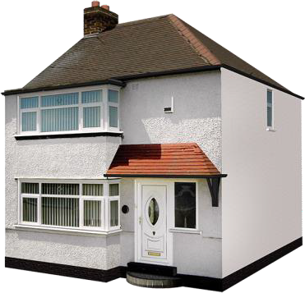
Our team includes:
- Nurses
- Support Workers
- Occupational Therapist
- Psychiatrist
- Psychologist
- Speech & Language Therapist

Together we will make plan.

The plan will help you to make changes so that you start to feel better.
Our staff will deliver training to the people who support you.

This means family or carers can support you better.

Contact us
Community Intensive Support Service
32 Firshill Rise, Sheffield, S4 7BW
 0114 226 1562
 CLDTBusinessSupport@shsc.nhs.uk
We are open 9 a.m. - 5 p.m. Monday to Friday

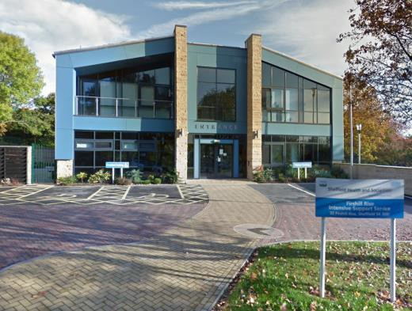 | 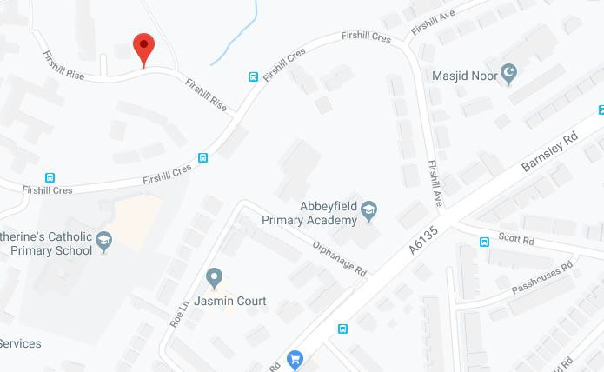

 | Useful contacts
Community Learning Disability Team |  | Grenoside Grange, Sheffield, S35 8QS   0114 2261562
Out of Hours Team  Monday to Friday 8 p.m. to 8 a.m. and weekends |  |  0114 2263636   OOH.Duty@shsc.nhs.uk
Sheffield Helpline - for anyone with mental health issues  (24 hours a day, 7 days a week) |  |  0114 2263636
Sheffield IAPT  IAPT supports the psychological well-being of people in Sheffield. |  |  0114 226 4380  http://iaptsheffield.shsc.nhs.uk/
The Samaritans  (24 hours a day, 7 days a week) |  |  (0114) 2767277 or 116 123
Sheffield Social Services  (24 hours a day, 7 days a week) |  |  0114 273 4908
NHS 111 - Call 111 when it is not an emergency but you need medical  help fast |  |  111
Accident and Emergency (A&E) |  | Northern General Hospital, Herries Rd, Sheffield S5 7AU   0114 243 4343   999 in an emergency
Online support |  | Every Mind Matters https://www.nhs.uk/oneyou/every-mind-matters/  Sheffield Mental Health Guide https://www.sheffieldmentalhealth.co.uk/

