This is my
Health Passport
Making health care safe and personal
My Name Is:

If I attend a health appointment this passport should be given to staff to read as it gives important information about me.

This document belongs to me.
Please ensure that I take my copy with me when I leave the appointment
Mental Capacity
Health Care Staff: Please look at my passport before you provide care and treatment to me.
Anybody else; please ask me for permission before you look at my passport.

Remember: As a Health Provider you need to gain my consent for my care and treatment or make decisions in my best interest in line with the Mental Capacity Act (2005) and Deprivation of Liberty Safeguards (DoLS).
This is an information document NOT a decision making tool

Information within this passport has been gathered from people who know me well.

Please check later in this document for when this information was last updated and confirm any important information.

Date this passport was completed:
This Passport should be updated if anything changes
Annual Review Date:
 | 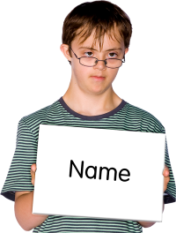 | My full name:  I like to be known as:
 |  | Date of Birth:
 |  | Home Address:
 | 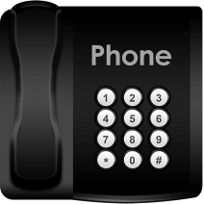 | Telephone Number:
 |  | NHS Number:
Ethnicity:
Religion and any religious needs:
 | 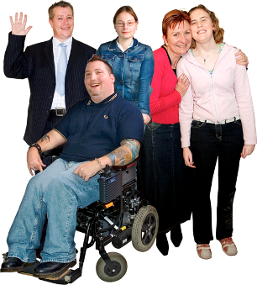 | Key Contacts i.e. Emergency Contact and their relationship e.g Mum, Dad, Advocate, Friends, Support Staff:  Contact 1:  Name:  Telephone:  Contact 2:  Name:  Telephone:

My Likes and Dislikes

Likes: For example – What makes me happy? What do I enjoy doing i.e. watching TV, reading, listening to music, my routines, talking to people etc

Dislikes: For example – What makes me sad? What do I not like, i.e. Shouting, being told what to do, food I do not like, physical touch etc
Things I like (please do these):

Things I don’t like (Don’t do these):

 | How I Communicate
 | 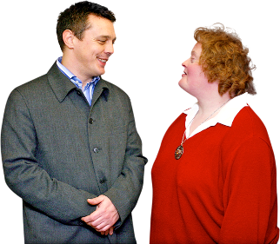 |  | How I communicate & what language I speak:
 |  |  | Please check if I use anything to help me communicate e.g. pictures, MAKATON, sign language, natural gestures?
 | 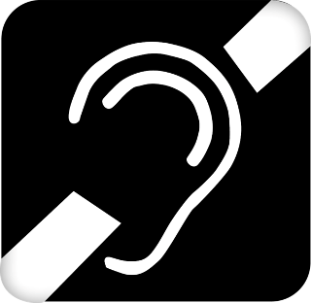 |  | Sensory information e.g. sight, hearing and touch:
 |  |  | How I say hello:
 | 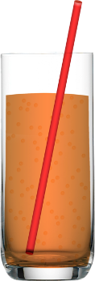 | How I say I would like a drink and my favourite drink:
 | 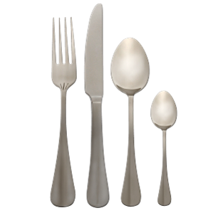 | How I say I am hungry:
 |  | The foods that I like:
 |  | The foods that I don’t like:
 |  | How I show I am happy or unhappy:
 | 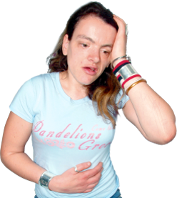 | How you know I am in pain and where is it:

 | My Medical Information
 |  |  | My illnesses that I know about:
 |  |  | Please check with my GP for details.
 | 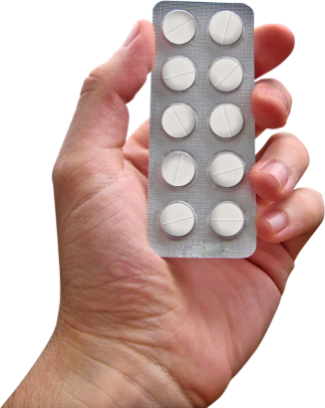 |  | Current prescribed medication that I know that I  take and what I take it for:
 |  |  | Please check with my GP that this is still correct!
 | 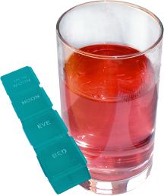 |  | How I usually take my Medication (tablets, injections, liquid):
 |  |  | Allergies:
 | 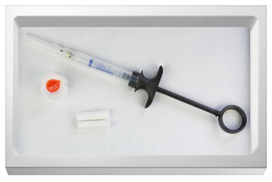 |  | Medical interventions – (How to take my blood,  give injections, blood pressure etc):
 |  |  | Heart or breathing problems:
 |  |  | Risk of choking, Dysphagia (eating, drinking and swallowing):
How I Eat (help to cut up food, risk of choking,
other help to eat):

 |  |  | How I Drink (usual quantities, thickened fluids, likes, dislikes):
 | 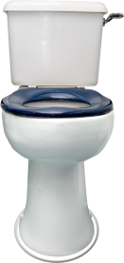 | How I usually use the toilet (Continence aids, help getting to the toilet):
 | 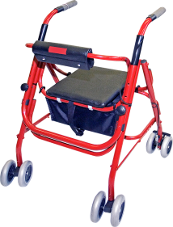 | Moving around (posture in bed, walking aids, transferring):
 | 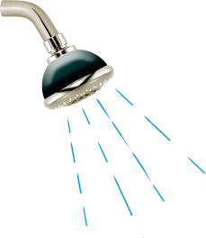 | Help I need with personal care (washing, dressing etc):
 |  | Sleeping (Sleep pattern / routine):
 | 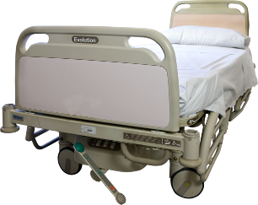 | Pressure care (any support I need with this):
 |  | How I keep safe (bed rails, support with challenging behaviour):
 |  | Sensory Needs (Do I struggle with light, noise, crowded areas?):
 |  | Do I need a quiet space?

My Other Support Needs
My support needs & who gives me the most support:

Notes:

Other Health and Social Care Professionals who Support Me
(e.g. Physiotherapists, Social Worker)
 | Name of Person | What Support does this Person Provide (e.g. Dietician) | Contact Details
 | https://www.mencap.org.uk/get-involved/campaign-mencap/current-campaigns/treat-me-well

